TRAN VAN ON PRIMARY SCHOOL  Ngày kiểm tra: ............................ | THE SECOND SEMESTER TEST: GRADE 2  School year: 2023-2024  Time: 35 minutes
Full name: ……………………………………………….. - Class: 2……..

Marks | Listening | Reading | Writing | Speaking | GV coi  (kí, ghi rõ họ tên) | GV chấm  (kí, ghi rõ họ tên)

Comment: ..................................................................................................................................................

LISTENING (4pts)
PART 1. Questions 1- 4. Listen and tick (✓) in the box. (1pt).
✓
Example: You hear: 0. A.This is a duck. The answer is:

 | 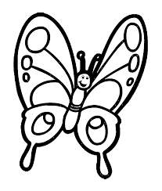 | 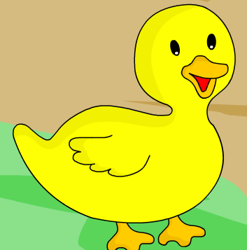
0. |  | ✓
 | 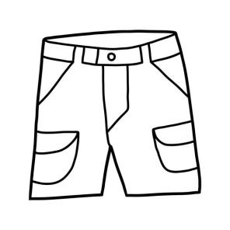 | 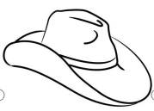 |  | 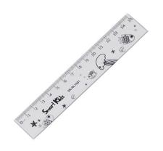 | 
1 |  |  | 2
 | 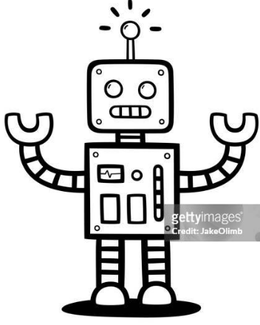 | 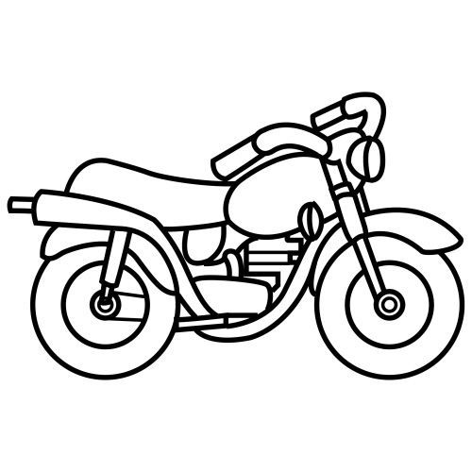 |  | 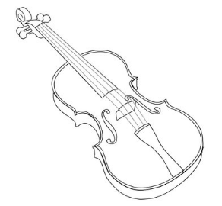 | 
3 |  |  | 4

PART 2. Questions 5-8. Listen and number in order. There is one example. (1pt).
0
Example: You hear: 0. I’ve got a robot. The answer is:

0

A.  | B. | C.  | D. 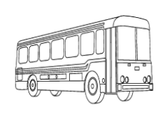 | E.
PART 3. Questions 9- 12. Listen and match. There is one example. (1pt).
Example: You hear 0. How old are you? I’m eight.
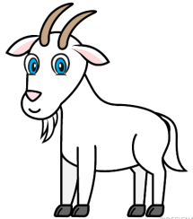  A | 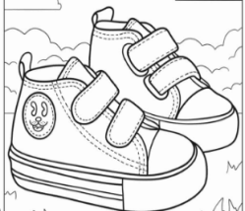  B | 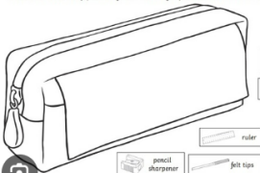  C | 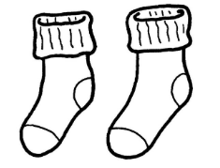  D | 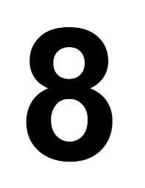  F
0 | 9 | 10 | 11 | 12

PART 4: Questions 13- 16. Listen and circle A or B. (1pt).
There is one example.

0.    A |   B

13. 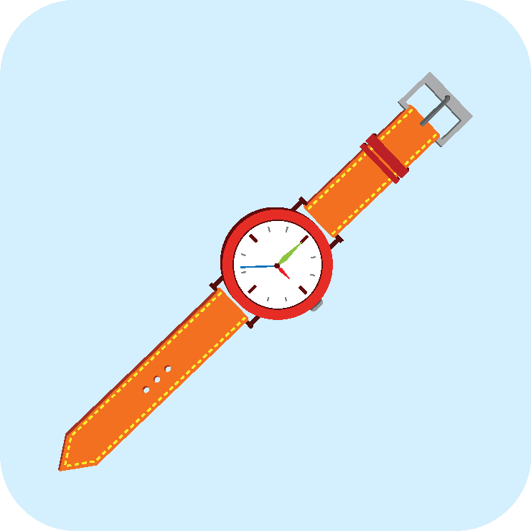  A | 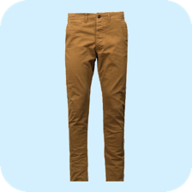  B | 14.  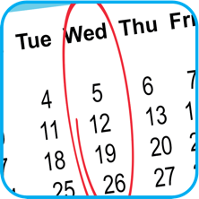 A |   B
15.   A |   B | 16. 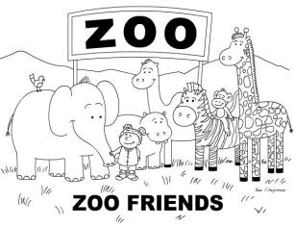  A | 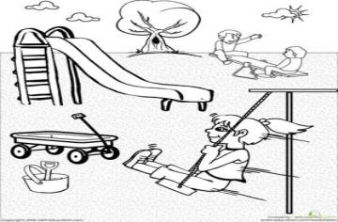  B

READING (2pts)
PART 1. Questions 1- 4. Read and match the pictures.There is one example (1pts)
0  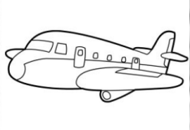 | 1   | 2  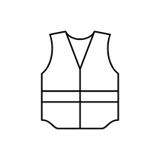 | 3  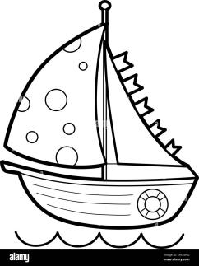 | 4  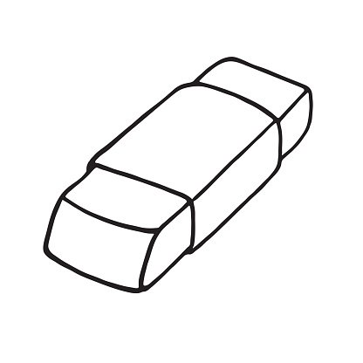

boat | Shirt | Eraser | plane | vest

PART 2. Questions 5- 8. Read and circle Yes or No. There is one example. (1pts)
0. The dog is in the box. | Yes  No
5.  She can’t sing. | Yes  No
6. 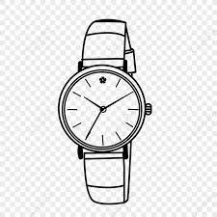 I can see the watch. | Yes  No
7.  I can count the number | Yes  No
8.  What day is it today?  It’s Sunday. | Yes  No

WRITING (2pts)
PART 1. Questions 1- 4. Choose a word from the box and fill in the blank. There is one example. (1pts)
Example:
0.  | => I’ve got chicken.
=> Can you see the .............................?
Yes, I can
2. | => These are the.........................
3. | => I can see the ........................
4. | => This is the.........................

PART 2. Questions 3- 6. Reorder the letters to make the correct words. (1pts)
There is one example.
Example: 0. i e l c b y c => bicycle |  | 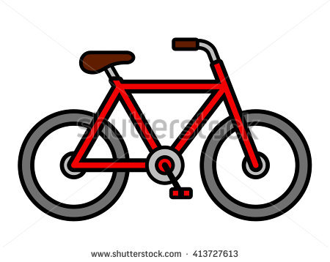
3. w w i n o d => ________________ | 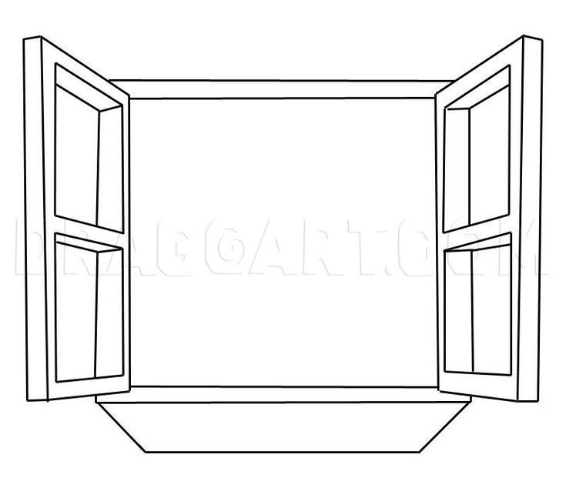
4. a l m b r u e l => ________________
5. a t w h c => _____________________
6. T- r t s h i => __ ________________ _ | 


